**Overview:**

A turn-based strategy game, where you play as one of the factions in Brockton Bay and attempt to survive and gain power in the city. You control teams of parahumans in your employ, and deploy them in fights against other teams and factions in order to gain resources, territory or reputation.

**Single-player or multiplayer:**

Optimally played multiplayer as all factions should be balanced and playable, but the size of the Worm fanbase may make this unfeasible. Singleplayer with AI opponents may be doable.

**Turn structure:**

A turn consists of 4 phases. These phases occur simultaneously for all factions, and choices are not revealed until the phase ends.

**Phase I:** All factions plan events and territory invasions.

**Phase II:** Events and invasions are revealed. Factions now can assign teams to fight for or against the aggressing side (event creator or invader).

**Phase III:** Victories, defeats, injuries and captures from the battlesare revealed. Changes in reputation, resources and territory ownership are tallied. Factions assign thinkers and tinkers *not* deployed in Phase 1 or Phase 2 to investigate or tinker respectively. Organizational changes e.g. moving parahumans between teams, are also executed in this phase.

**Phase IV:** Random or conditional events take place. Randomized trigger events take place during this time.

**Gameplay Elements**

**Factions:** Each faction has two major variables: reputation and resources. Reputation is analogous to "score", resources to "currency". Generally, you gain and lose reputation by winning and losing battles, and resources by keeping territory that you have won. When either reaches zero, the faction dissolves and its constituent teams become independent.

**Teams:** A team is a group of parahumans that must fight as a whole if deployed, excluding injured members. Teams can be owned by a faction or independent, and they can be allied with one or more faction. Each team has a threat rating (C, B, A, S) that indicates the level of force it has escalated to, and the acceptable level of force authorized against them.

**Parahumans:** Each parahuman is characterized by their power ratings and their health. Health is defined as one of four states: *Healthy*, *Injured*, *Down* and *Deceased*. Ratings follow Worm's PRT ratings: Brute, Blaster, etc. Only Master, Tinker and Breaker ratings can contain subratings.

**Territory:** Territories are "owned" by a faction at any one point in time. The owner receives resources from each piece of territory every turn. Territories are gained and lost in battle.

**Events:** Factions can stage events such as rallies, announcements or prisoner transports. Events last one turn, created in Phase I and completed at the end of Phase III. If an event is not attacked or the defending force is victorious, the event creator receives a reward depending on the type of event. A victorious attacking force can also receive rewards, e.g. the freeing of a parahuman in a prisoner transport.

**Information/Intelligence:** Not all information is known to all; factions maintain a "profile" of the city: the ratings of different parahumans, the resources of different factions, any hidden powers etc. Information is acquired passively when public events or battles happen, but also actively by deploying thinkers to investigate in Phase III.

**External factions:** When certain conditions are met, external factions can enter the city. Examples are the Slaughterhouse Nine which are attracted by conflict, the Triumvirate which is attracted by a strong A- and S-Class villain presence, the Fallen which is attracted by an Endbringer attack, etc. External factions leave the city when the prerequisite conditions are no longer present or when they are under sufficient threat.

**Scripted Events:** When certain conditions are met, scripted events can occur. Leviathan's, Echidna's escape and Gold Morning are examples. Possible events not covered in canon could be Coil's takeover of PRT leadership, other Endbringer fights, city quarantines, etc.

**Combat:**

Combat is determined by the ratings of the two opposing sides. Certain ratings buff/debuff the ratings of yourself and the enemy. Not all canonical ratings are included.

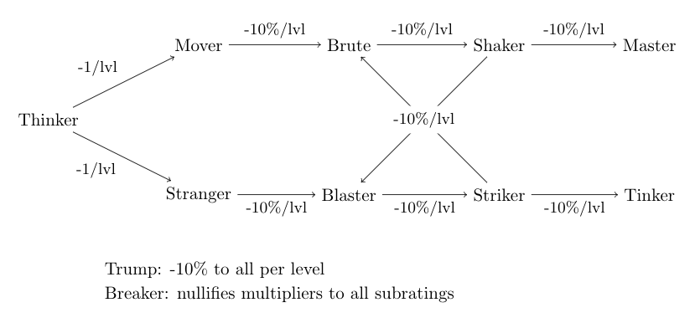

Attack power = Brute + Blaster + Shaker/2 + Striker/2 + <no. of team members>

Mobility = Mover + Stranger – <no. of team members>

Chance of injury and chance of escape is defined by comparing the attack power and mobility respectively of the two opposing sides.

**Threat Ratings and Acceptable Force:**

|  |  |  |
| --- | --- | --- |
|  | **Threat rating** | **Acceptable force** |
| **C** | Default | Injure |
| **B** | Downed a parahuman | Down |
| **A** | Killed a parahuman | Kill (lethal force) |
| **S** | Killed a whole team | Kill (lethal force) |

A team acquires the corresponding threat rating when the criterion in the first column is fulfilled, and the enemy they are deployed against is below that threat level. For example, killing an A-Class parahuman will not give you an A threat rating, but killing a B-Class will.

When a team is deployed in a battle, an acceptable force rating is also authorized. An authorized force of C will at most injure enemies, B will at most down enemies, etc.

Essentially, authorizing a force of level <X> carries the risk of pushing your own threat rating to <X>, unless your enemy is already of threat <X>.